|  |  |  |  |
| --- | --- | --- | --- |
| **CS102** | **Spring 2018/19** | Project Group | 1b |
| Instructor: | **David Davenport** |  |  |
| Assistant: | Mehmet Başaran |  |  |

|  |  |  |
| --- | --- | --- |
| **Criteria** | **TA/Grader** | **Instructor** |
| Presentation |  |  |
|  |  |  |
|  |  |  |
|  |  |  |
| Overall |  |  |

~ CITIZEN OF THE WORLD ~

KERATTA KERATTALAR

Burak Öçalan - Ahmet Işık - Batuhan Gelgi

Emin Adem Buran - Ahmet Kağan Uğuralp - Yusuf Ziya Özgül

|  |
| --- |
| UI-Design Report  ( Version 2.0 )  4 April 2019 |

# Introduction

The game we designed aims to make children learn general knowledge about countries all around the world and we add user colorful and funny interfaces to the game in order to attract attention of children. Game is turn based and it is played on the world map. On the basis of the game, players are asked questions about the countries and to be rewarded with the citizenships of those countries when they know three questions. This game can be played up to four players on a desktop, which means users will be in same place. When the player plays its turn, turn passes to the next player and first player should leave the computer. First player whose money runs out will leave the game and the game will continue for other players. When all the players leave the game except for the last one whose money still remains, the last player will get extra 3 citizenships as a reward. At the end of the game winner will be determined according to players’ number of citizenships.

# Details

There are two screens before the players start the game. The first one is the main menu; the second one is the player option menu. After the users make themselves ready for the game, they will go to playground where the users are going to spend most of their time and the game is being played.



## Main Menu

This screen will provide 5 options to user. First option is “New Game”. After players click this button, users will encounter another screen that presents player options to user such as selecting nick name. The second one is “Load Game”. After player clicks on this button, they will see some slots to choose to play saved games. Third option is “How to Play”. After player selects this button, the game will provide general features and rules of the game for the players. The fourth option is “Credits”. After player selects this option, they will see the designers of the game. Last of them is “Exit”. After players select this button, they will exit the game. The main menu will be displayed as the following.

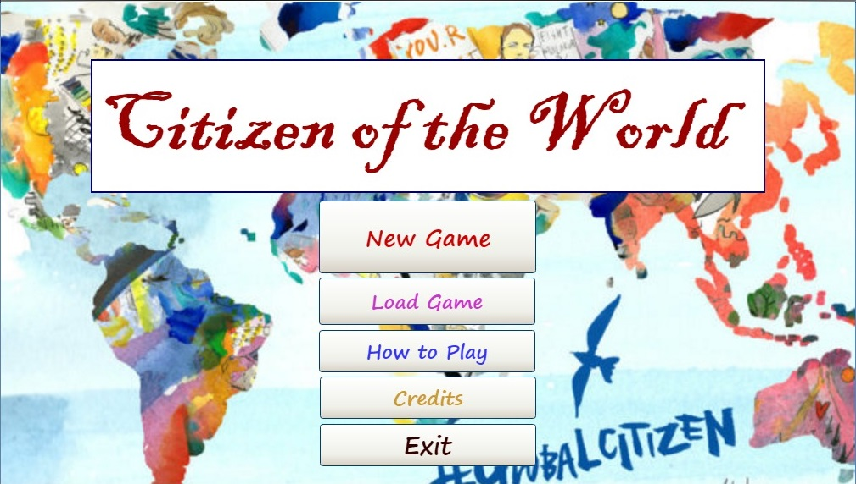

[1] Main Menu

## Player Options

After clicking the “New Game” button on the main menu, a new menu will appear. In this menu, there will be a few options about the players and the game. At the top, choose player number option determines the number of players in the game. The number of players can be selected as one, two, three or four. After selecting the number of players, each player will write their nicknames and select their nation. When the game begins, each player starts at their nation. Also players must select their avatars. After each player completes their preparations for the game, they can click “Start” button which is on the right bottom corner to start the game. Players can return the main menu by clicking “Back” button which is on the left bottom corner.

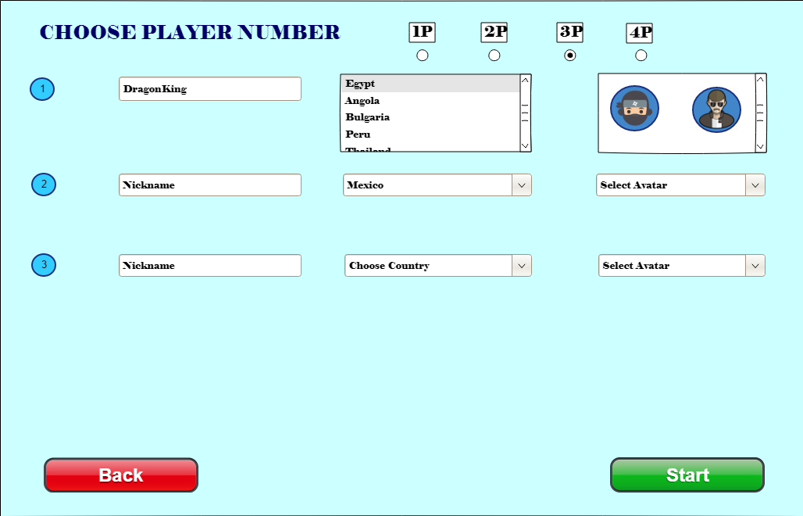

[2] Player Options Menu

## Playground

Players will spend most of their time in this screen. This screen will contain World Map at background. Players will see their current location with a specific diamond shape for each player and the route of the game (For example, as shown in the picture below this player is currently in Turkey. The player’s specific diamond shape, which is visible by the country name at the right top of the screen, is on the Turkey on the map). The route of the game which is showed with lines can be seen on the World Map. Players will start from the country selected in the previous menu and follow this route throughout the game. At the top left corner, player can see their current money with his avatar. Also, we can learn which player’s turn is by looking the color of the avatars on the right panel. The avatar whose background is orange will indicate which player’s turn is. The general structure of playground will be the following picture.

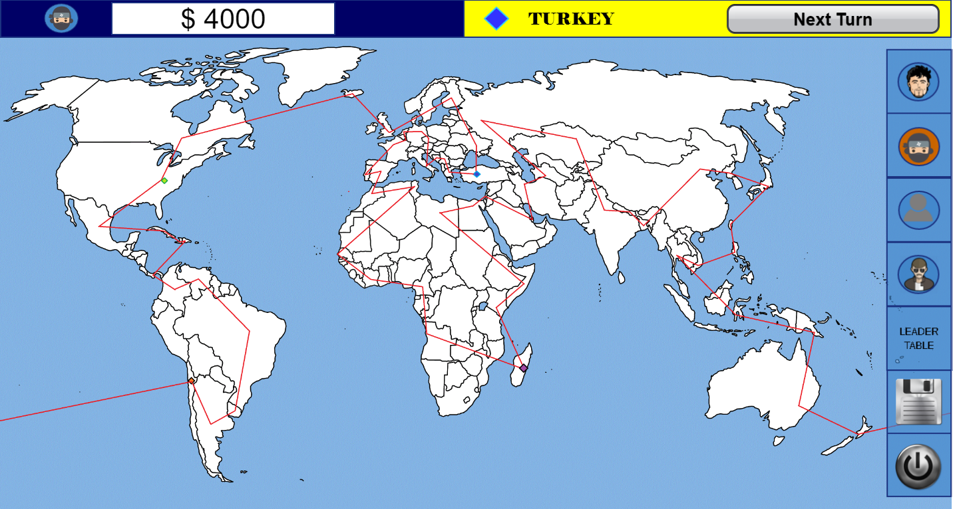

[3] Playground

Also, users will be able to see the status of the other players and the leadership table at the right edge of this screen. When they click the profile of another user, the following screen will seem.

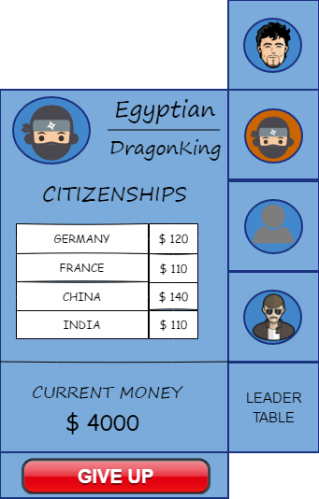

[4] Player Panel

The picture above tells us about the details of players. All current citizenships and money will be able to seen by other players. Details of player cannot be observed directly on playground screen. In order to see details, player should click on little signs at the right edge of screen. Without clicking, just little signs will appear. In this way, we will make playground screen simpler. Also, players can save and exit the game by clicking on the images at the right bottom corner. These buttons can be seen in the following picture.

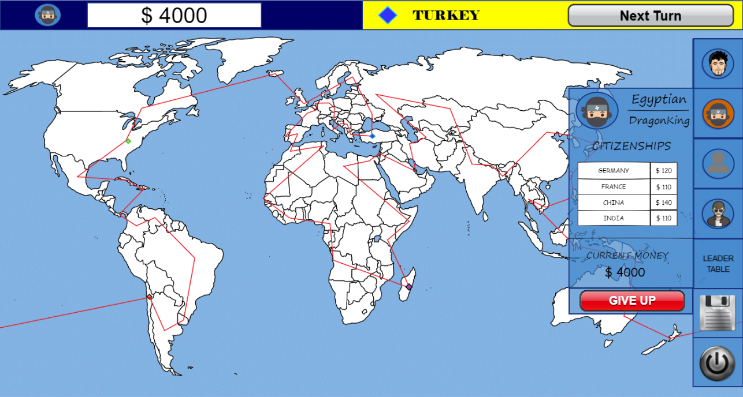

[5] Playground with Player Profile

Also, there is a button on the right edge of the screen called “LEADER TABLE” to see the rank of the players. When the player clicks on the Leadership button, the stats of the players will be shown next to the avatars’ buttons. To exit from the leadership table, player should click on “LEADER TABLE” button again. The rank system is based on the citizenship numbers. Whoever has the most citizenships, that player will be shown at the top leadership. If two players’ number of citizenships are the same, the money will be considered as in the example below.

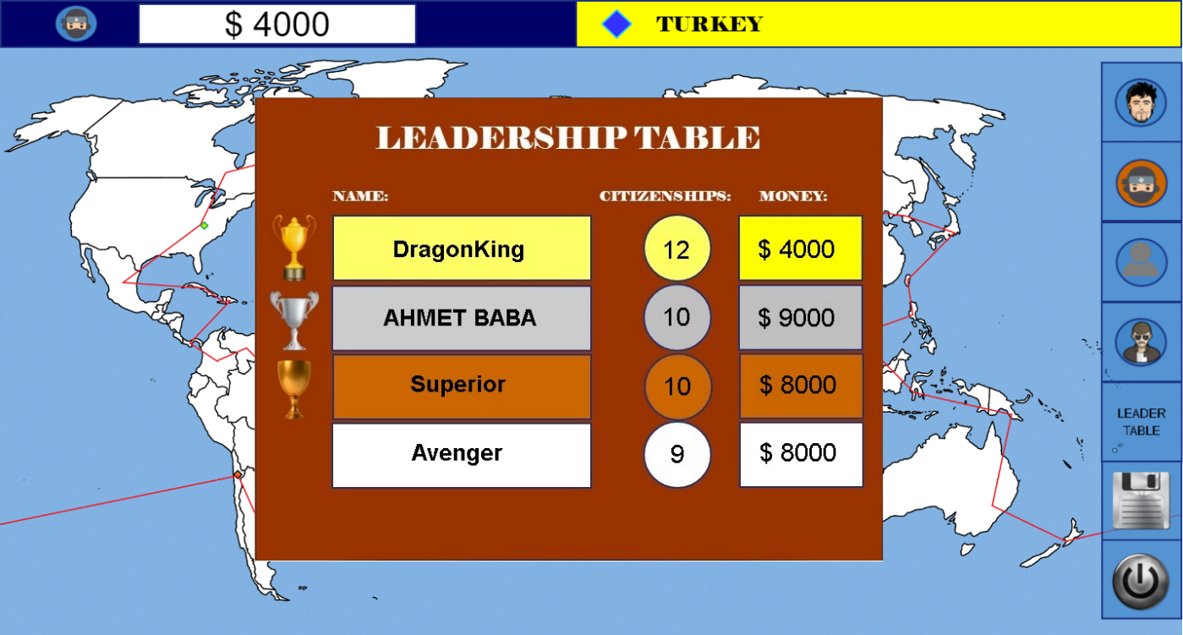

[6] Playground with leadership table

Additionally, each country will have its profile. When the player comes to a country, player will see the profile of country. In this profile, the accommodation fee, the citizenship fee and the income of this country will be seen. The player will be able to choose between two options: pay accommodation fee and get citizenship. This screen can be seen at the next page.

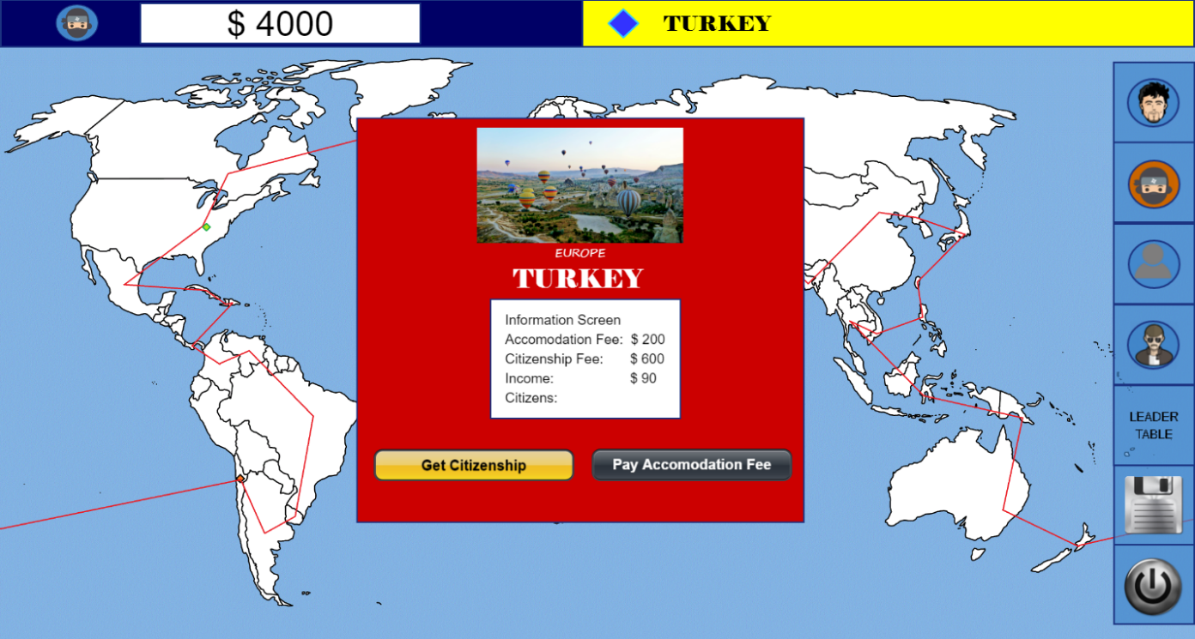

[7] Playground with Country Profile

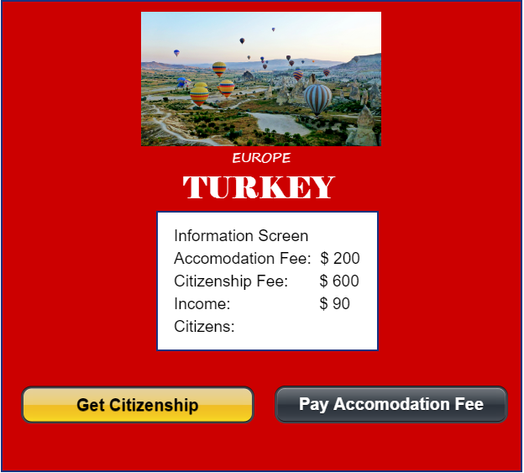

[8] Country Profile

If the players want to see their current citizenships, they have always chance to click on the avatar to see details of the player. By this way, they can make a strategy whether to get questions or not by considering current money and the tax comes from the countries of which the player is a citizen. The strategy will be important because to get the citizenship from the country, player has to know random three questions about that country. If the player doesn't even know one of the questions, the player will lose much more money than accommodating in that country. This will make it harder for the player to last longer.

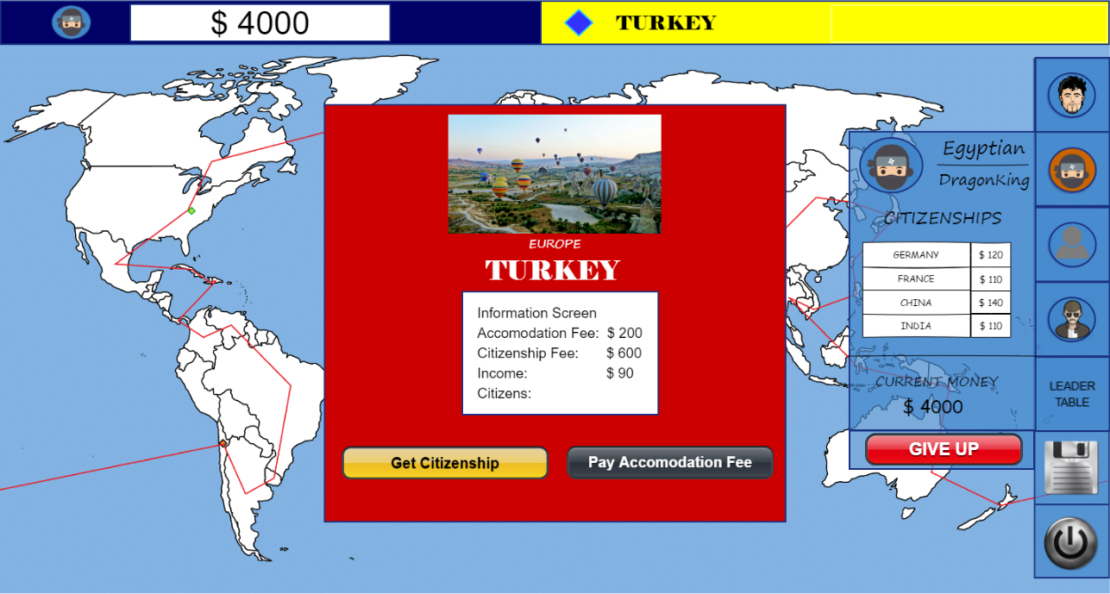

[9] Playground with Country And Player Profile

If the user wants to pay accommodation fee, game will get the accommodation fee from the user with following screen and will wait for the player to click the exit button on the pop-up.

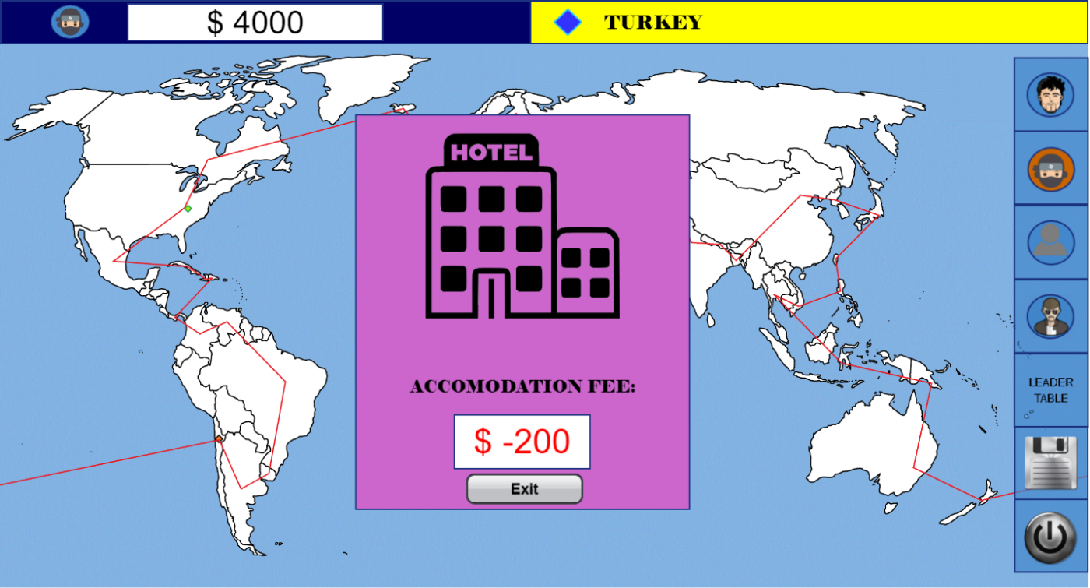

[10] Playground with Accommodation Panel

If the user wants to get citizenship from this country, three questions will be asked to the player. While answering the question, user will have a specific time (in the example below, given 10 seconds to answer the question) which changes according to the question types and their difficulties to answer it. The number next to text “QUESTION” shows the question number among three questions (in this example, the player still tries to find the answer for the first question between three). In this panel just the answer parts will be clickable. The user cannot click on any parts of question panel but answer buttons. Questions will be seen on the screen as the following picture.

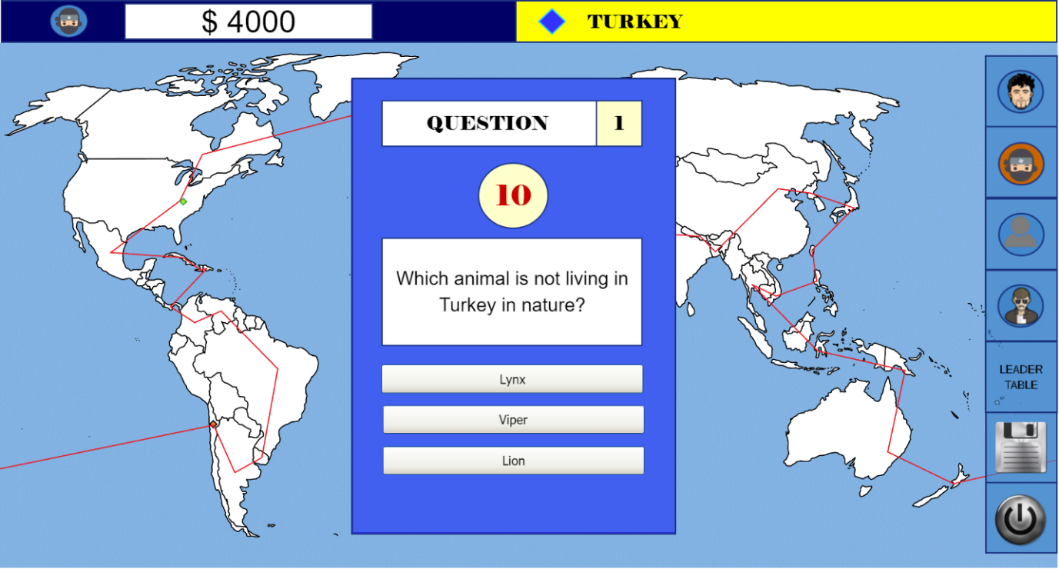

[11] Playground with Questions Panel

When player answers the question wrongly, the following picture will seem on the screen. Even if the player gives a wrong answer in the first one among three questions, the player cannot see the others. Game will get the citizenship fee, which is taken per question, from the user with following screen and will wait for the player to click the exit button on the pop-up.

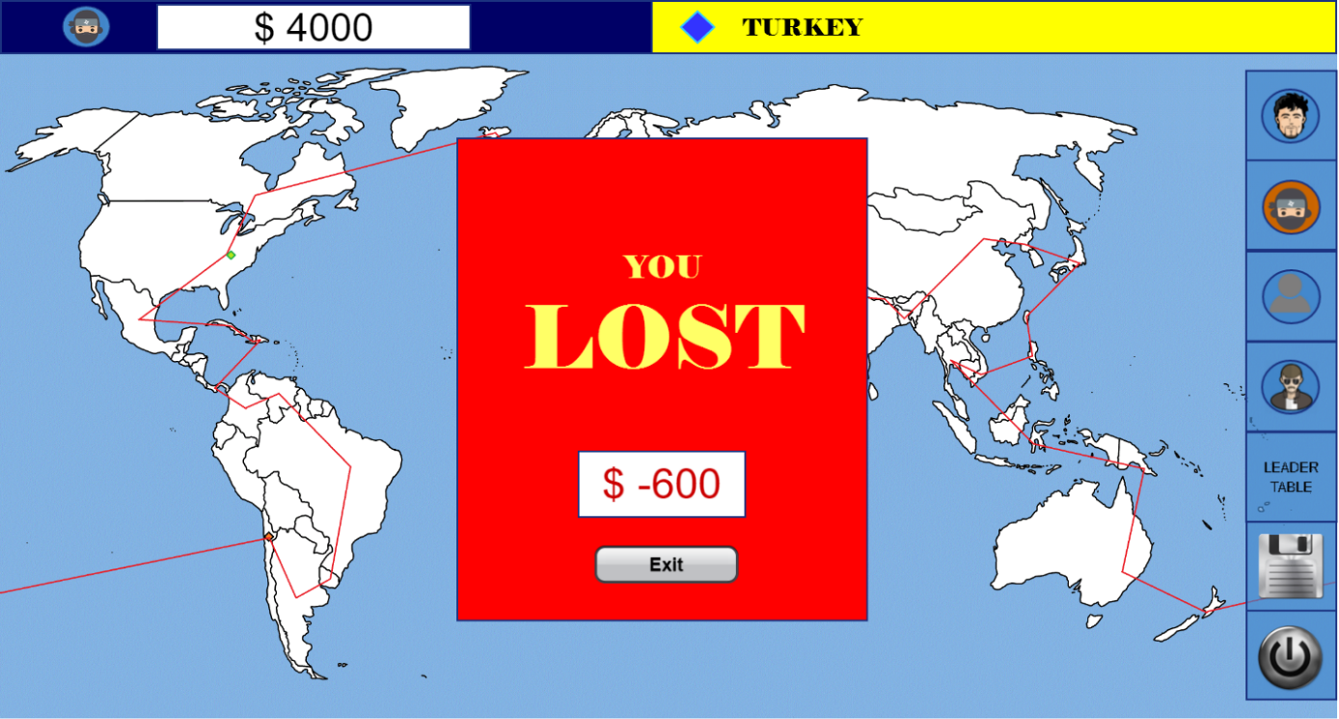

[12] Playground with Lost Panel

When the user can answer all questions correctly, they will be the citizen of this country and the following panel will appear on the screen. In below picture, we give a real estate investment as an income source. There will be also different type of investments to create variety and make game realistic. These investments will change from country to country. For example; when player invest his money to real estate in Turkey, he will earn money by having a taxi station in Brazil. This panel will stay on the screen until the user clicks on “Exit” button. By the way, even if the user knows all the questions, there will a charge of getting citizenship which is $ 600 in this example below.

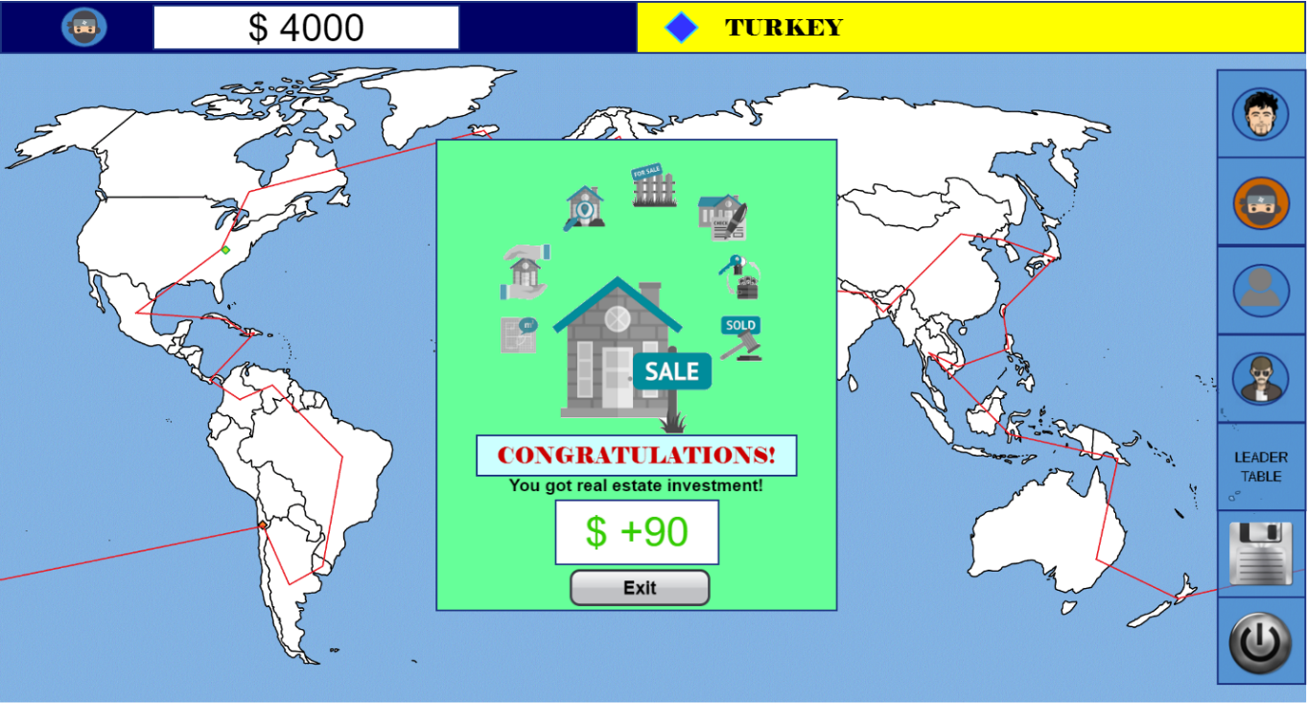

[13] Playgroud with Win Panel

After the questions are asked or the choice of paying the accommodation is paid, this screen comes again without any pop-up opened on it. This means the turn of the player has passed and the game waiting for the next player to click on the “Next Turn” down of the screen. In this screen, before to pass to next player, players will have chance to click on their avatars to see their details to make strategy if they want.

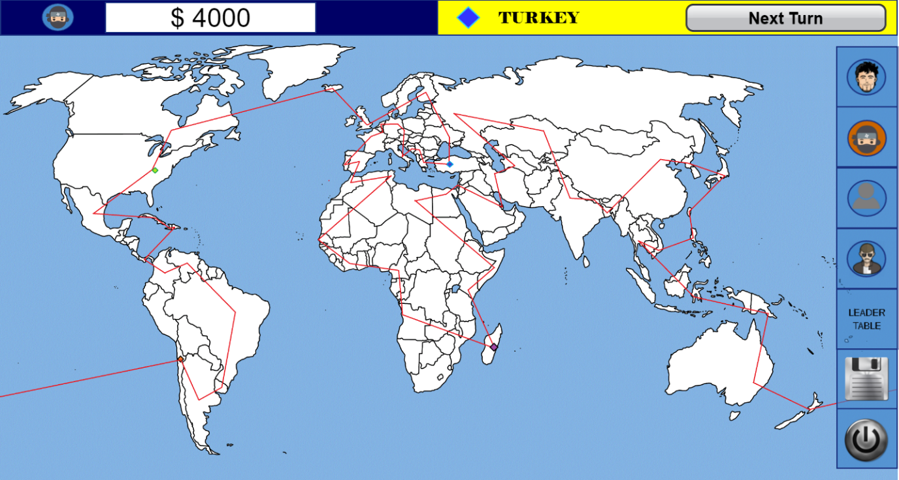

[14] Playground with Next Turn Button

After clicking on the “Next Turn” button, the pop-up below will be opened on the screen which waits for the player to click on the button “THROW THE DICE” to roll the dice for the player’s travel.

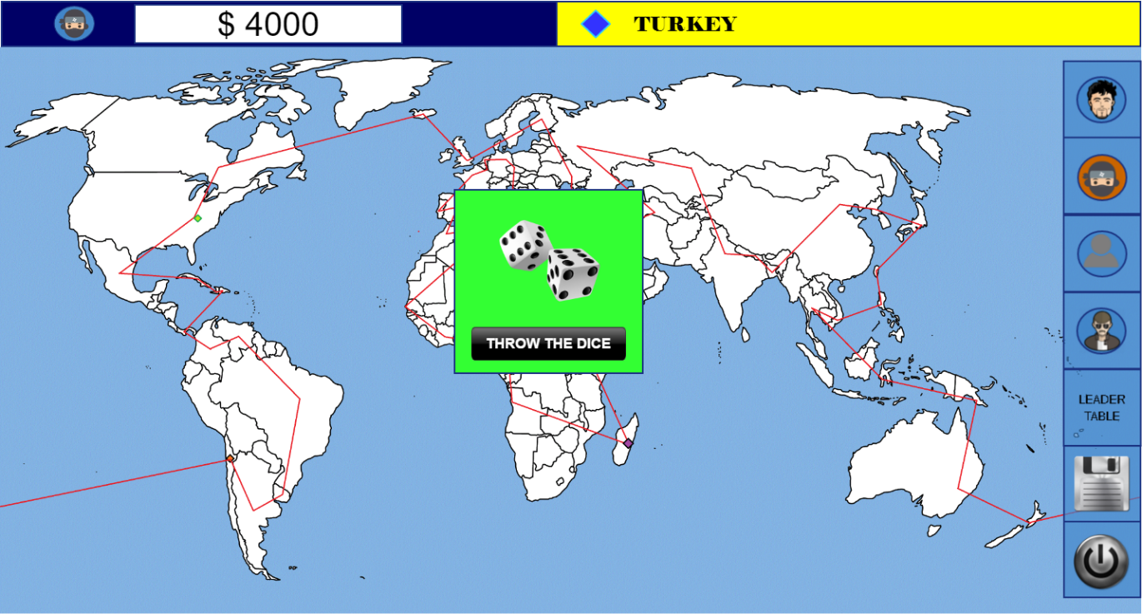

[15] Playground with Dice Panel

Later on, a new pop-up comes on the screen which displays the result of the dice rolling and travel cost according to the length of the way. This cost is cut from the player’s current money. This pop-up will stay until the player clicks on the “See the Country” button on it. When the player clicks on the button exit, the country’s profile screen which is the player arrives will be opened, and the process will go like this.

Additionally, whenever the players want, they can click on the save button which is shown on the right edge of the screen with a picture “disk”.

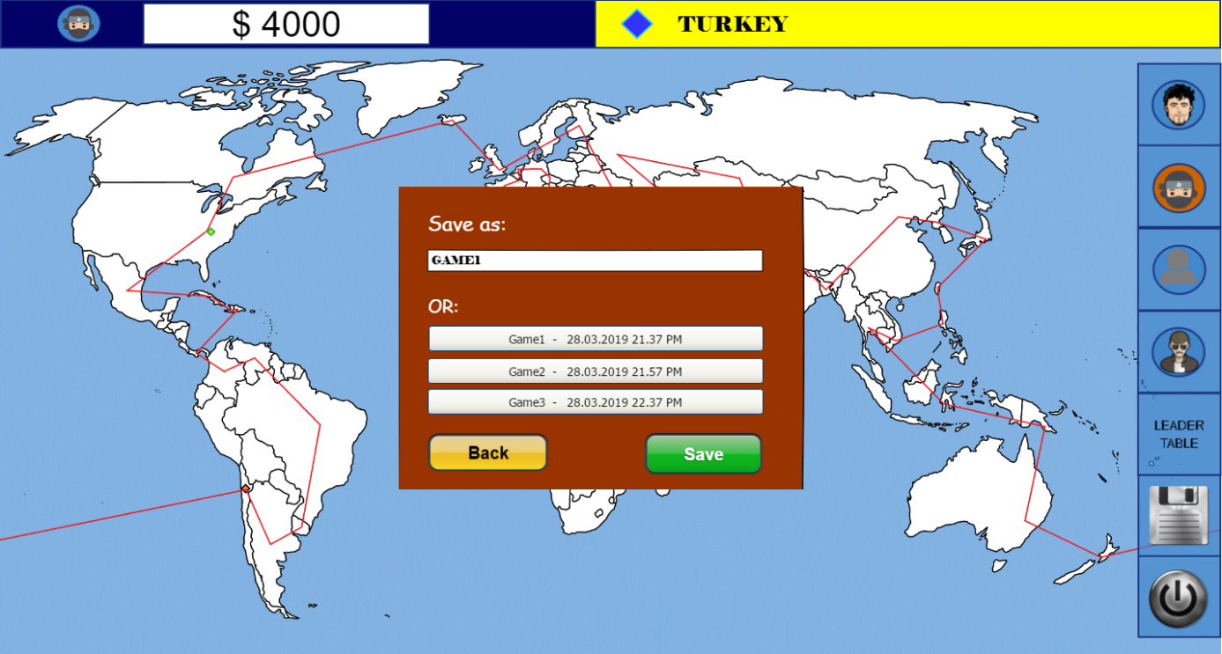

[16] Playground with Save Panel

Whenever the players want, they will be able to exit the game by clicking on the power button on the right edge of the screen. After clicks on it, there will be new Option Pane to make the user sure whether the player wants to exit or not. Also, there will be a button between yes or no called “save” in case the user forgets to save the game. If the player chooses yes, the game will be closed without saving it. If the user wants to save the game and clicks on save button in the middle, the previous option pane will display to save the game.

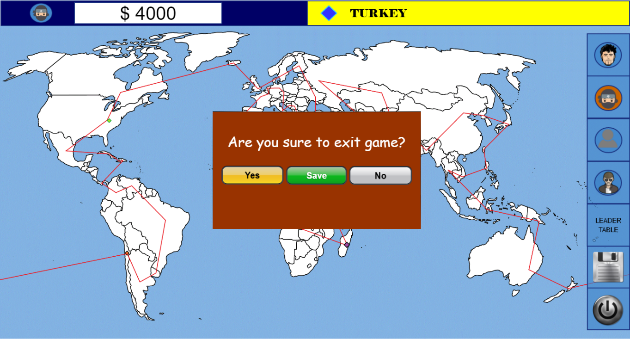

[17] Playground with Exit Panel

## Load Game

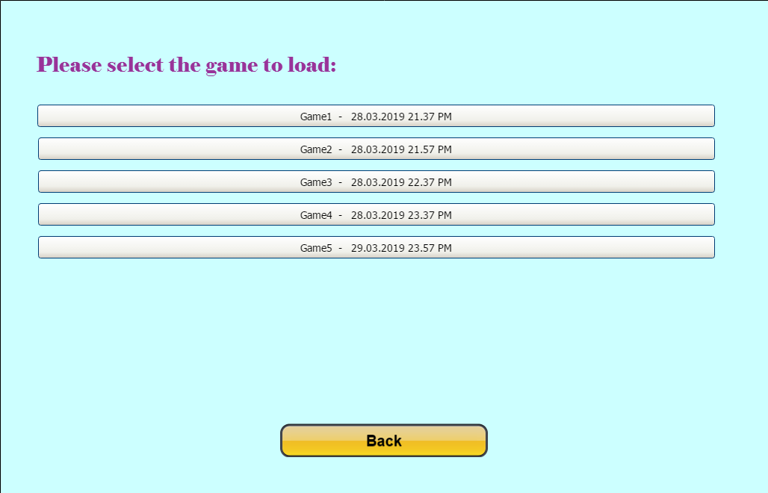

[18] Load Game Menu

After clicking the “Load Game” button on the main menu, a new menu will appear. In this menu, there will be a few slots about previous saved games which can specifically be named. After clicking the game which the player wants to continue, saved game will be opened.

# Summary & Conclusions

In short, we described various graphical interfaces above. They will be used to ease users’ work during the game. As our main audience will be children, we will make everything simplest so that they can understand what they must do to play the game. We will focus more detailed on our graphical interfaces design in next stages of project. Although our graphical interfaces were described above, we can think of how we can improve this to make it more convenient for children.

References

1. Baebaek. “'Avatar' by Baebaek.” *Iconfinder*, www.iconfinder.com/icons/1499757/avatar_character_man_ninja_profile_thief_user_icon
2. “Computer Icons User Profile Avatar - French People - Unlimited Download. Kisspng.com.” *Kisspng.com*, www.kisspng.com/png-computer-icons-user-profile-avatar-french-people-2286084/
3. *Clear World Map* #699341, pasarelapr.com/detail/clear-world-map-21.html.
4. “Dark Power Button Icon #8345 - Free Icons and PNG Backgrounds.” *Freeiconspng.com,* www.freeiconspng.com/img/8345
5. “Global Citizen - Beauty and Well.” *Being*, 6 Feb. 2017, beautyandwellbeing.com/well-being/global-citizen/.
6. Iconshock. “Save’ by Iconshock.” *Iconfinder*, https://www.iconfinder.com/data/icons/BrushedMetalIcons_meBaze/512/Save-01.png
7. Iconshock. “'Trendy Guys' by Iconshock.” *Iconfinder*, www.iconfinder.com/icons/60496/andrew_avatar_head_human_man_user_icon
8. Jurgaitis, Romualdas. “'Avatars' by Romualdas Jurgaitis.” *Iconfinder*, www.iconfinder.com/icons/2640415/avatar_cop_mustache_police_profile_shades_user_icon
9. “Pencil Project.” *Home - Pencil Project*, pencil.evolus.vn/.